EYFS Reception Expectations/ ELG GEOGRAPHY
EYFS | Autumn | Spring | Summer
ELG most closely linked to Geography | Understanding the world (People and communities) Children know about similarities and differences between themselves and others, and among families, communities and traditions.  Understanding the world (The world) children know about similarities and differences in relation to places, objects, materials and living things. They talk about the features of their own immediate environment and how environments might vary from one another.
Key concepts – Super 6! | - I know the name of my school and where it is (Crays Hill, Essex, England)  - I know the different areas of my classroom and can find the things I need – writing area, my tray, my peg, sand tray, garden etc  - I can create plan of my classroom and talk about it.  - I know the names of different areas of my school – corridor, hall, toilets, playground, field, forest schools, office, HT office, red area, blue area etc  - I know how to find my way to different areas of the school and can show a friend how to get there too.  - I can label different areas of the school on an aerial view. | - I can name a range of features in the immediate environment (trees, pond, fields, house, roundabouts, school, playground field etc)  - I can create a map remembering to add key features – roads, buildings, trees, fields etc  - I can label the key features on a map  - I can describe key features on a map using positional language (behind, in front, next to- i.e. the field is next to the school)  - I can describe a simple route on a map using directional language (forward, turn, across, along, around)  - I can enter a local destination on google earth and describe what I can see using my geographical language. | - I know our school is in a village in the countryside and can use my observational skills to identify the key features around us. (little roads, fields, farms, trees, hills, post office, local shop)  - I can look at a seaside environment and identify the key features (sea, beach, sand, stones, fairground, promenade, cliffs, light house, coast, rockpools)  - I can identify what features are the same and what features are different when comparing a village and the seaside.  - I can identify villages and the seaside using a range of aerial photos.  - I can find land and sea on a map of the UK  - I know what a map, globe and atlas is and can discuss what I see using some of the vocabulary that I have learned.
Vocabulary | School  Classroom  Corridor  Hall  Kitchen  Field  Playground  Red/ blue/ green/ wooden area  Toilets  Secret garden  Forest school area  Plan | Map  Local area  School  Home  Houses  Flats  Forwards  Turn  Left  Right  Road  Direction  Next to  Behind  Infront | Seaside  Coast  Town  Lighthouse  Beach  Village  Little roads  Fields  Farms  Trees  Hills  Post office  Local shop
Link book | The gingerbread man/ The Three little Pigs | The Naughty Bus/ Hattie Peck: The Journey Home | The Whale Who Wanted More
Geographical skills and field work | Walk of school and school grounds  Google maps aerial view of school  School plans of building  Photographs of different areas of the school | Local walk around the immediate area surrounding school  Google Earth | Link to school trip to seaside  Maps  Atlas  Globe
WAGOL | 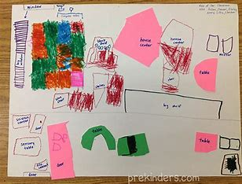  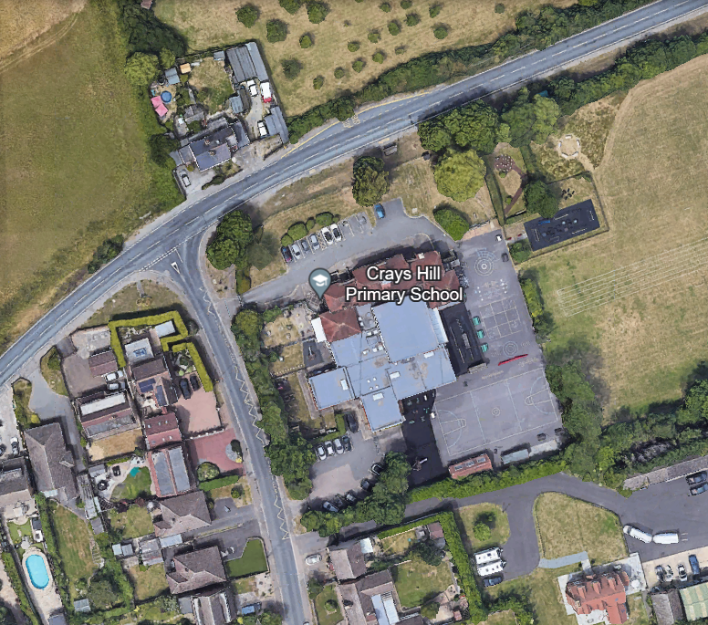 | 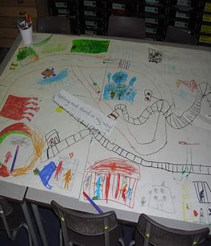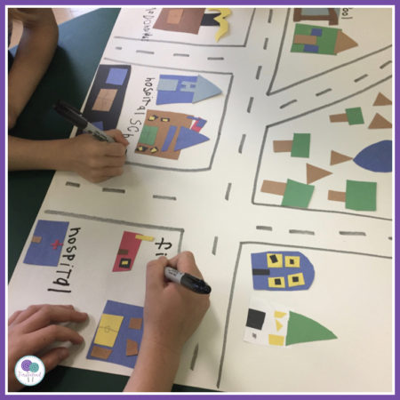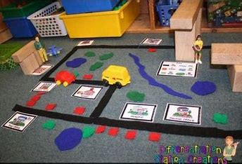 | 

