Year 6 | Autumn | Spring | Summer
National Curriculum | Locational knowledge  ▪ locate the world’s countries, using maps to focus on Europe (including the location of  Russia) and North and South America, concentrating on their environmental regions,  key physical and human characteristics, countries, and major cities  ▪ name and locate counties and cities of the United Kingdom, geographical regions and  their identifying human and physical characteristics, key topographical features  (including hills, mountains, coasts and rivers), and land-use patterns; and understand  how some of these aspects have changed over time  ▪ identify the position and significance of latitude, longitude, Equator, Northern  Hemisphere, Southern Hemisphere, the Tropics of Cancer and Capricorn, Arctic and  Antarctic Circle, the Prime/Greenwich Meridian and time zones (including day and  night)  Place knowledge  ▪ understand geographical similarities and differences through the study of human and  physical geography of a region of the United Kingdom, a region in a European country,  and a region within North or South America  Human and physical geography  ▪ describe and understand key aspects of:  ▪ physical geography, including: climate zones, biomes and vegetation belts, rivers,  mountains, volcanoes and earthquakes, and the water cycle  ▪ human geography, including: types of settlement and land use, economic activity  including trade links, and the distribution of natural resources including energy,  food, minerals and water  Geographical skills and fieldwork  ▪ use maps, atlases, globes and digital/computer mapping to locate countries and  describe features studied  ▪ use the eight points of a compass, four and six-figure grid references, symbols and key  (including the use of Ordnance Survey maps) to build their knowledge of the United  Kingdom and the wider world  ▪ use fieldwork to observe, measure, record and present the human and physical  features in the local area using a range of methods, including sketch maps, plans and  graphs, and digital technologies.
Previous knowledge | Children will be able to locate and name the seven continents.  Children will be able to identify the equator and lines of latitude and longitude.  Children will know what is meant by a habitat. They can name some habitats and which animals may live in them.  Children will know some ways in which we can protect our local environment. (Science links) | Children can use a key to identify features on a map.  Children know the difference between human and physical features.  Children can use co-ordinates to find a location.  Children can draw a simple map.  Children know the points of a compass. | Children can identify whether food has been grown or produced.  Children know that some food is imported from other countries and that some food is grown in the UK.
Topic | Biomes | Local Fieldwork | Farms and factories: where does our food come from?
Key concepts | I know what a biome is and can identify their climate conditions, flora and fauna.  I can identify the location of different biomes and examine which biomes occur at different latitudes  I can identify the different factors that affect an ecosystem (rainfall, temperature, sunlight, human activity)  I can identify the different characteristics of the tundra, taiga and grasslands  I can explore the different ways that biomes are being protected and preserved  I can answer the question ‘are all biomes equally fragile?’ | I know why geographers do field work and the tools they use  I know why maps are important, how they are used and can use grid references  I can create a sketch map and a field sketch of my local community  I know the difference between a geographers survey and questionnaire and can create some examples.  I can develop an enquiry question  I can collect data and present my information | I can describe the processes involved in commercial bread production.  I can describe how food production, processing and distribution has changed over time and identify potential positive and negative impacts of these changes.  I can explain the impact that climatic and seasonal differences have on food availability.  I can explain what food miles are and analyse the positive and negative impacts of both locally produced and imported food.  I can understand and explain reasons why some people don’t have enough to eat and share my opinions about potential actions that can be taken to help end world hunger.  I can describe ways in which farming and food production have changed over time and investigate ways of taking action to make food systems fairer and better for our planet and its people.
Vocabulary | biome, climate, flora, fauna, equator, latitude, longitude, rainforest, deciduous, evergreen, taiga, tundra, savannah, desert, rainfall, temperature, sunlight, human activity, deforestation, pollution, environment, habitat, protect, preserve, fragility, fragile | Geographer, fieldwork, physical feature, human feature, sketch map, field sketch, key, questionnaire, enquiry, data, graph, chart | Bread, grain. Harvest, grown, produced, flour, factory, farm, crops, factory, processed, distribution, import, climatic change, seasonal, distance, food miles, world hunger, prevent, support, Fair Trade
Knowledge mat | 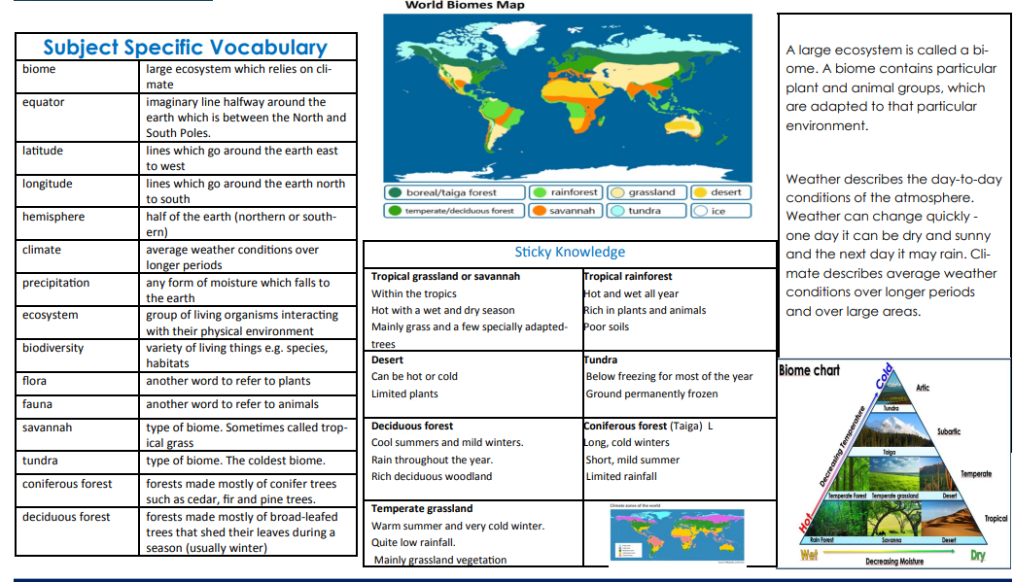 | 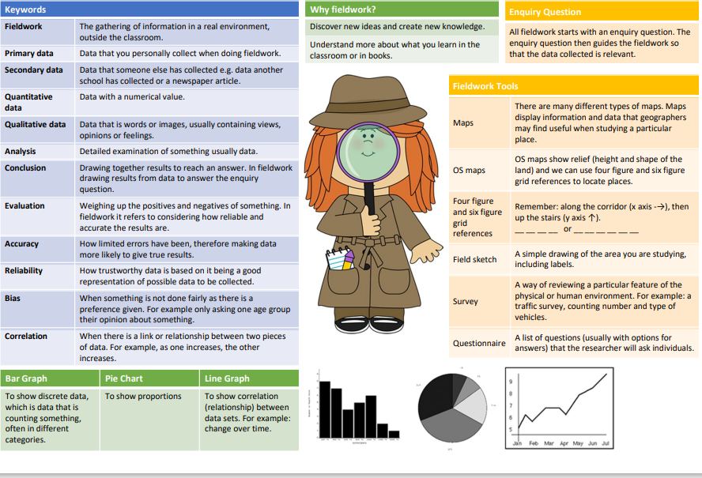
Link book | Greenwild by Pari Thomson   | The Streets Beneath my Feet  By Charlotte Guillan and Yuval Zommer  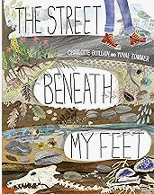 | Farm Boy by Michael Morpurgo  

